



User Manual

Preamble

© 2011 IncrediSoft

All rights reserved. No parts of this work may be reproduced in any form or by any means – graphic, electronic, or mechanical, including photocopying, recording, taping, or information storage and retrieval systems – without the written permission of the publisher.

Products that are referred to in this document may be either trademarks and / or registered trademarks of the respective owners. The publisher and the author make no claim to these trademarks.

While every precaution has been taken in the preparation of this document, the publisher and the author assume no responsibility for errors or omissions, or for damages resulting from the use of information contained in this document or from the use of programs and source code that may accompany it. In no event shall the publisher and the author be liable for any loss of profit or any other commercial damage caused or alleged to have been caused directly or indirectly by this document.

Definitions

This document uses certain terms that may be confusing and or ambiguous. This section attempts to clarify what these terms mean within the context of iLearn.

Student | A student is an individual which is assigned to a class during registration.
Class | This refers to the collective group of students taking the same subjects at the same time. It is not to be confused with Subject.
Subject | This is a lesson taken by a class . A class takes many subjects which occur during different time slots.

Table of Contents

Part I – Starting iLearn . . . . . . . . . 4

Part II – Logging In . . . . . . . . . . 4

Part III – Main Window . . . . . . . . . 5
Changing Your Password . . . . . . . . 6
Logging Out . . . . . . . . . . 6
Exiting iLearn . . . . . . . . . . 6

Part I - Starting iLearn

To start iLearn double click the icon named iLearn on your desktop.
Alternatively, you can locate it from your Start menu under the folder iLearn.


Part II - Login

You must enter a user name and password to access iLearn. That user name and password will be supplied by the System Administrator.

After starting iLearn, you will be presented with the login screen below:
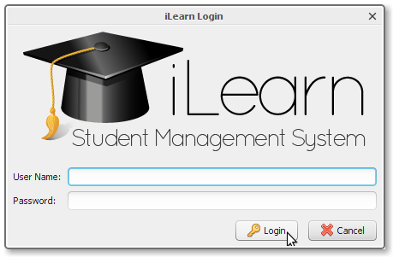

Type in the user name and password supplied by the System Administrator and click the Login button. If login is successful, the login window will disappear and the program will load the main window. Once logged in, the system will keep a record of your actions.

If your user name and / or password do not match those on file, you will be asked to enter them again. You have three chances to login before the program exits.

Part III - Main Window

The main window is shown below:

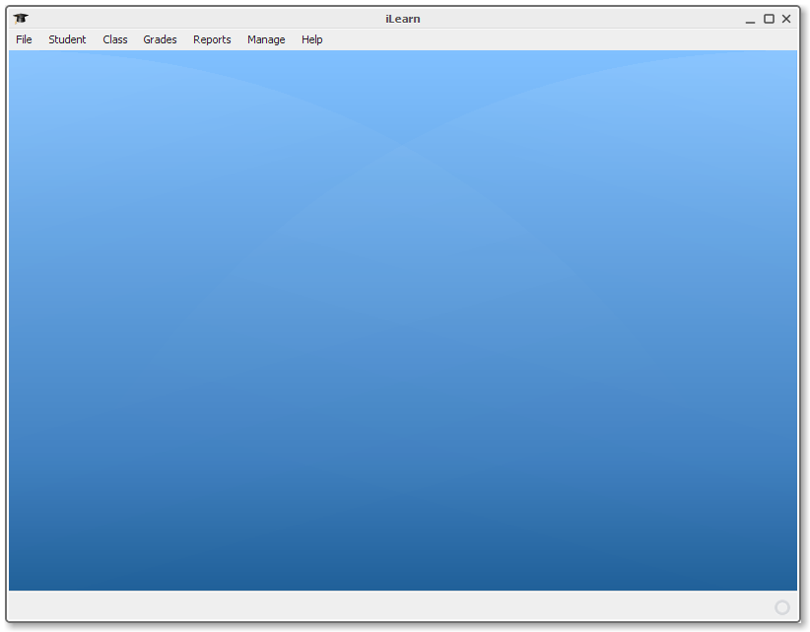
Depending on your level of access, some of the menu choices will be disabled.
Changing Your Password

Change your password often in order to avert any identity theft.
To change your password select File → Change Password from the main menu.

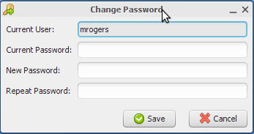
- Enter your current password and new password in the respective fields.
- Enter your new password once more in the repeat password field to ensure you don't have any mistakes in your new password that would prevent you from logging in later.
- Click Save to save the changes

Logging Out

Logging out enable someone else to use the program with the privileges granted to them. For example if a Head of Department wishes to override a grade or action.

To log out select File → Logout from the main menu.
The program will ask you to confirm if you want to logout. If you select Yes all open windows will be closed, the menu will be disabled and the login screen will appear.

At this point, the program is ready to accept another user's credentials and grant him / her the appropriate access.

If No is selected the program will simply return to its previous state.

Exiting iLearn

Exiting iLearn will also log you out of the system.

To exit iLearn select File → Exit from the main menu. The program will ask you to confirm if you want to exit. If you select Yes all open windows will close and the program will shutdown.

Part IV – Students

The student module allows you to add, edit and view student information. This module is responsible for handling the students' personal information and class assignments.

